**Structure**

Every program in Java must be developed within a class.

class myClass

{

static void main(String[] args)

{

}

}

For the Console application, all the code should be inserted inside the main method shown below:

static void main(String[] args)

{

// code is inserted here

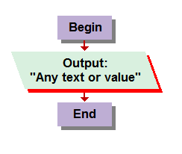 }

**Output (Printout)**

To display a message in Java we use:

System.out.print (“Any text or value”);

System.out.print("cursor will be at the end “ +

“of this“line if .Write is used");

System.out.println ("cursor will be at the next line if .WriteLine is used");

**Input (Reading Values)**

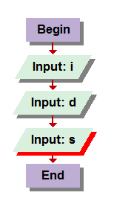At the top of the program add the following API

import java.util.*;

Before asking the user to enter the first value, add the following statement:

Scanner scan = new Scanner (System.in);

Prompt the user to enter a value:

System.out.print ("Enter a value: ");

Get the value and save it in a variable matching type:

int i = scan.nextInt();  
double d = scan.nextDouble();  
String s = scan.nextLine();